Chapter 11 AP Statistics Practice Test
[Notes/Highlighting]
Section I: Multiple Choice Select the best answer for each question.
T11.1. A chi-square goodness-of-fit test is used to test whether a 0 to 9 spinner is “fair” (that is, the outcomes are all equally likely). The spinner is spun 100 times, and the results are recorded. The degrees of freedom for the test will be
- (a) 8.
- (b) 9.
- (c) 10.
- (d) 99.
- (e) None of these.
Correct Answer
b
Exercises T11.2 and T11.3 refer to the following setting. Recent revenue shortfalls in a midwestern state led to a reduction in the state budget for higher education. To offset the reduction, the largest state university proposed a 25% tuition increase. It was determined that such an increase was needed simply to compensate for the lost support from the state. Separate random samples of 50 freshmen, 50 sophomores, 50 juniors, and 50 seniors from the university were asked whether or not they were strongly opposed to the increase, given that it was the minimum increase necessary to maintain the university’s budget at current levels. The results are given in the following table.
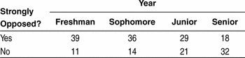
T11.2. Which hypotheses would be appropriate for performing a chi-square test?
- (a) The null hypothesis is that the closer students get to graduation, the less likely they are to be opposed to tuition increases. The alternative is that how close students are to graduation makes no difference in their opinion.
- (b) The null hypothesis is that the mean number of students who are strongly opposed is the same for each of the four years. The alternative is that the mean is different for at least two of the four years.
- (c) The null hypothesis is that the distribution of student opinion about the proposed tuition increase is the same for each of the four years at this university. The alternative is that the distribution is different for at least two of the four years.
- (d) The null hypothesis is that year in school and student opinion about the tuition increase in the sample are independent. The alternative is that these variables are dependent.
- (e) The null hypothesis is that there is an association between year in school and opinion about the tuition increase at this university. The alternative hypothesis is that these variables are not associated.
Correct Answer
c
T11.3. The conditions for carrying out the chi-square test in exercise T11.2 are
- I. Separate random samples from the populations of interest.
- II. Expected counts large enough.
- III. The samples themselves and the individual observations in each sample are independent.
Which of the conditions is (are) satisfied in this case?
- (a) I only
- (b) II only
- (c) I and II only
- (d) II and III only
- (e) I, II, and III
Correct Answer
e
Exercises T11.4 to T11.6 refer to the following setting. A random sample of traffic tickets given to motorists in a large city is examined. The tickets are classified according to the race of the driver. The results are summarized in the following table:
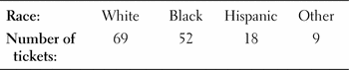
The proportion of this city’s population in each of the racial categories listed above is as follows:
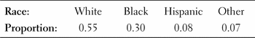
We wish to test H₀: The racial distribution of traffic tickets in the city is the same as the racial distribution of the city’s population.
T11.4. Assuming H₀ is true, the expected number of Hispanic drivers who would receive a ticket is
- (a) 8.
- (b) 10.36.
- (c) 11.
- (d) 11.84.
- (e) 12.
Correct Answer
d
T11.5. We compute the value of the χ² statistic to be 6.58. Assuming that the conditions for inference are met, the P-value of our test is
- (a) greater than 0.20.
- (b) between 0.10 and 0.20.
- (c) between 0.05 and 0.10.
- (d) between 0.01 and 0.05.
- (e) less than 0.01.
Correct Answer
c
T11.6. The category that contributes the largest component to the χ² statistic is
- (a) White.
- (b) Black.
- (c) Hispanic.
- (d) Other.
- (e) The answer cannot be determined since this is only a sample.
Correct Answer
c
Exercises T11.7 to T11.10 refer to the following setting. All current-carrying wires produce electromagnetic (EM) radiation, including the electrical wiring running into, through, and out of our homes. High-frequency EM radiation is thought to be a cause of cancer. The lower frequencies associated with household current are generally assumed to be harmless. To investigate this, researchers visited the addresses of a random sample of children who had died of some form of cancer (leukemia, lymphoma, or some other type) and classified the wiring configuration outside the dwelling as either a high-current configuration (HCC) or a low-current configuration (LCC). Here are the data:
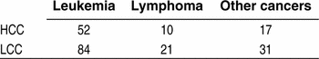
Computer software was used to analyze the data. The output is given below. It includes the cell counts, some of the expected cell counts, and the value of the χ² statistic. In the table, expected counts are printed below observed counts and enclosed within parentheses.
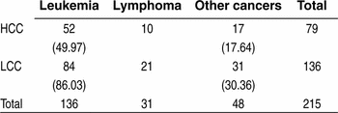
T11.7. The appropriate degrees of freedom for the χ² statistic is
- (a) 1.
- (b) 2.
- (c) 3.
- (d) 4.
- (e) 5.
Correct Answer
b
T11.8. The expected count of cases with lymphoma in homes with an HCC is
- (a) 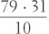.
- (b) 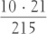.
- (c) 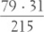.
- (d) 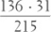.
- (e) None of these.
Correct Answer
a
T11.9. Which of the following may we conclude, based on the test results?
- (a) There is strong evidence of an association between wiring configuration and the chance that a child will develop some form of cancer.
- (b) HCC either causes cancer directly or is a major contributing factor to the development of cancer in children.
- (c) Leukemia is the most common type of cancer among children.
- (d) There is not much evidence of an association between wiring configuration and the type of cancer that caused the deaths of children in the study.
- (e) There is weak evidence that HCC causes cancer in children.
Correct Answer
d
T11.10. A Type I error would occur if we conclude that
- (a) HCC wiring caused cancer when it actually didn’t.
- (b) HCC wiring didn’t cause cancer when it actually did.
- (c) there is no association between the type of wiring and the form of cancer when there actually is an association.
- (d) there is an association between the type of wiring and the form of cancer when there actually is no association.
- (e) the type of wiring and the form of cancer have a positive correlation when they actually don’t.
Correct Answer
d
Section II: free Response Show all your work. Indicate clearly the methods you use, because you will be graded on the correctness of your methods as well as on the accuracy and completeness of your results and explanations.
T11.11. A large distributor of gasoline claims that 60% of all cars stopping at their service stations choose regular unleaded gas and that premium and supreme are each selected 20% of the time. To investigate this claim, researchers collected data from a random sample of drivers who put gas in their vehicles at the distributor’s service stations in a large city. The results were as follows:
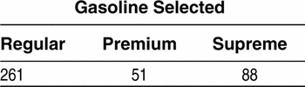
Carry out a significance test of the distributor’s claim. Use a 5% significance level.
Correct Answer
State: We want to perform a test at α = 0.05 of H₀: p_{regular} = 0.6, p_{premium} = 0.2, p_{supreme} = 0.2 versus H_{a}: At least one of the p_{i}’s is incorrect. Plan: Use a chi-square goodness-of-fit test if the conditions are satisfied. Random: A random sample was used. Large sample size in which the expected counts are 240, 80, and 80, all of which are at least 5. Independent: It seems reasonable that there would be more than 4000 people who stop at this gas station over a long period of time. Do: The test statistic is χ² = 13.15 and the P-value is 0.0014 using df = 2. Conclude: Since the P-value is less than 0.05, we reject H₀ and conclude that the distribution of type of gas purchased is not what the distributor claims.
T11.12. A study conducted in Charlotte, North Carolina, tested the effectiveness of three police responses to spouse abuse: (1) advise and possibly separate the couple, (2) issue a citation to the offender, and (3) arrest the offender. Police officers were trained to recognize eligible cases. When presented with an eligible case, a police officer called the dispatcher, who would randomly assign one of the three available treatments to be administered. There were a total of 650 cases in the study. Each case was classified according to whether the abuser was subsequently arrested within six months of the original incident.⁴⁰
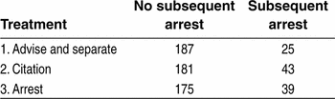
- (a) Explain the purpose of the random assignment in the design of this study.
- (b) Construct a well-labeled graph that is suitable for comparing the effectiveness of the three treatments.
- (c) We want to use these data to perform a test of H₀: p₁ = p₂ = p₃, where p_{i} = the true proportion of spouse abusers like the ones in this study who would be arrested again within six months after receiving treatment i. State an appropriate alternative hypothesis.
- (d) Assume that all the conditions for performing the test in part (b) are met. The test yields χ² = 5.063 and a P-value of 0.0796. Interpret this P-value in context. What conclusion should we draw from the study?
Correct Answer
(a) Random assignment was used to create roughly equivalent groups of subjects to receive each of the three possible treatments.
(b)
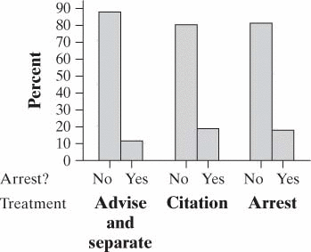
(c) The alternative hypothesis is that at least one p_{i} is different from the others. (d) If the proportion of subsequent arrests is the same for all three techniques, we have a 7.96% chance of getting a difference between the three groups as large as or larger than the one observed (χ² = 5.063) in this study due to the random assignment. We fail to reject H₀. We do not have enough evidence to say that the techniques lead to different subsequent arrest rates.
T11.13. In the United States, there is a strong relationship between education and smoking: well-educated people are less likely to smoke. Does a similar relationship hold in France? To find out, researchers recorded the level of education and smoking status of a random sample of 459 French men aged 20 to 60 years.⁴¹ The two-way table below displays the data.
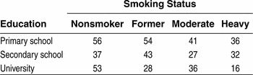
- (a) Is the relationship between smoking status and educational level statistically significant? Give appropriate evidence to support your answer.
- (b) Which cell in the table contributes most to the relationship in part (a)? Justify your answer.
Correct Answer
(a) State: We want to perform a test of
- H₀: Smoking status and education are independent among French men aged 20 to 60
- H_{a}: Smoking status and education are not independent among
at the α = 0.05 level. Plan: Use a chi-square test for association/independence if the conditions are satisfied. Random: The data came from a random sample. Large sample size in which the expected counts are 59.48, 50.93, 42.37, 34.22, 44.21, 37.85, 31.49, 25.44, 42.31, 36.22, 30.14, 24.34. All these counts are at least 5. Independent: There are at least 4590 French men aged 20 to 60. Do: The test statistic is χ² = 13.305 and the P-value is 0.0384 using df = 6. Conclude: Since the P-value is less than 0.05, we reject H₀ and conclude that education and smoking status among French men aged 20 to 60 are not independent. (b) The largest contribution is from the university-educated males who are heavy smokers—there are far fewer of them than expected.

